**CM 1900 - Intelligent Machines Inspirational Project**

**B.Sc.(Hons) Artificial Intelligence**

**Group 01**

|  |  |
| --- | --- |
| Admission No | Name |
| 225511E | Epasinghe S.K |
| 225520F | Helapalla K.O.R.I |
| 225507X | Dhananjana R.A |
| 225529P | Nimraka T.M.N |
| 225537M | Randinu L.L |

**DualPlay**

**The Ultimate Two-Side Air Hockey Experience with an Intelligent Opponent**

Table of Contents

**Introduction:** 3

**Game Modes:** 3

**System objectives:** 3

**How The Game Works:** 3

**System Components and Sensors** 5

**System Functions** 7

**1.** **Wired Remotes** 7

**2.** **Table (Main System)** 7

• **Ball Tracking** 7

• **Paddle Move Mechanism** 7

• **Ball Pushing Mechanism** 8

• **Score tracking** 9

• **Ball Redeploy Mechanism** 9

**Block Diagram** 10

**Design** 11

**References** 12

# **Introduction:**

The project aims to create an engaging and interactive multiplayer table game that combines the excitement of air hockey with innovative features such as autonomous gameplay modes and customizable gameplay options. The game, titled " **DualPlay: The Ultimate Two-Side Air Hockey Experience with an Intelligent Opponent**", will provide players with a unique and enjoyable gaming experience that encourages social interaction, strategic thinking, and friendly competition.

## **Game Modes:**

* **Human vs Intelligent player(system)**
* **Human vs Human**

# **System objectives:**

* Provide an entertaining and enjoyable game that promotes relaxation and mental stress relief.
* Create a multiplayer experience that encourages social interaction and friendly competition among players.
* Encourage Human Players to Engage in Duels, Challenging and Defeating the Intelligent System player for Ultimate Victory
* Implement autonomous gameplay modes to accommodate varying numbers of players and ensure an enjoyable experience regardless of player availability.
* Enhance gameplay with visual cues through LCD displays to indicate scores and an integrated sound system for an immersive experience.
* Develop user-friendly interfaces for selecting gameplay modes and keeping track of scores.

# **How The Game Works:**

The game supports multiple play modes to cater to different numbers of players.

**1. Game Initialization:**

* The LED displays show the main menu with the available gameplay modes.

**2. Mode Selection:**

* Player(s) approach the table and select their desired gameplay mode using the buttons on the table.
* Available modes include,
  + - Human vs Intelligent system (1v1)
    - Human vs Human (1v1)
* The system will then prompt for the number of points required for a player to win.

**3. Player Setup:**

* **Human vs Intelligent system (1v1)** – A human player takes their position at one side of the table and controls their paddle using the corresponding wired remote. The opposing side is autonomously guided by the intelligent system.
* **Human vs Human (1v1)** – Both human players take their respective positions at the table and control their paddles using individual wired remotes for each side.

**4. Ball Placement:**

* The ball will be automatically launched onto the table from one player's side, initiating the start of the game.

**5. Game Start:**

* Players use their remote controls to move their paddles and start hitting the ball. In cases where the intelligent system is participating, it autonomously guides its paddle by tracking the ball’s position.
* The game begins and players try to hit the ball into their opponent's goal to score points.

**6. Scoring a Goal:**

* When a player successfully hits the ball into their opponent's goal, a point is scored.
* The LCD displays update the score, and the sound system emits a celebratory sound to mark the achievement.

**7. Ball Reset:**

* Following a scored point, the ball is automatically launched onto the table from the side of the player who did not score the point.

**8. Score Tracking:**

* The LCD displays update the scores for each player in real-time.
* Players can easily see the current score without interrupting the game.

**9. Autonomous Gameplay (Human vs Intelligent system (1v1)):**

* Here, the system controls one side of the table.
* The Intelligent opponent(system) uses computer vision to track the ball’s position to move the paddle correctly to provide a challenge to the player.

**10. Match Completion:**

* The game proceeds until one player achieves the predefined winning score.

**11. Game Over:**

* The game concludes when a player wins the match.
* The LCD displays show the final scores and show who is the winner, and the sound system produces a victory sound.

**12. Reset for New Match:**

* Players can choose to start a new match, change modes, or end the session.

**13. Power Down:**

* When the gaming session is complete, the game can be powered down.
* Scores and settings are reset for the next session.

# **System Components and Sensors**

|  |  |  |  |
| --- | --- | --- | --- |
| Item name | Price | No. of items | Total |
| Raspberry Pi 3 Model B * | 21650 | 1 | 21650 |
| Arduino Mega | 5800 | 1 | 5800 |
| Kingston MicroSD 32GB | 1900 | 1 | 1900 |
| 5V 3A Micro USB Power Adapter (Raspberry Pi) | 1050 | 1 | 1050 |
| DS-212 Green 16mm Round Metal Push Button Momentary Switch | 100 | 4 | 400 |
| DS-212 Red 16mm Round Metal Push Button Momentary Switch | 100 | 2 | 200 |
| Continuous Rotation SG90 Servo Motor Plastic Wheel Full Set Normal (360 degrees) | 350 | 4 | 1400 |
| 4x3 Matrix Array Keypad Switch Module | 750 | 1 | 750 |
| 1602 16x2 Blue Backlight LCD Display | 360 | 3 | 1080 |
| IIC/I2C/TWI/SPI Serial Interface Board Module Port for 1602 LCD Display PCF8574T | 230 | 3 | 690 |
| Camera Module v1.3 5MP 1080p 720p for Raspberry Pi 3 and 2 | 1350 | 1 | 1350 |
| 15-Pin Ribbon Cable 50cm Flex CSI Raspberry Pi Camera | 100 | 1 | 100 |
| 17HS8401 NEMA 17 Stepper with wire 0.52Nm (D Shaft 5mm) | 2900 | 2 | 5800 |
| Creality Ender EN-PLA White 1.75mm 1Kg 3D Printer Filament | 5600 | 1 | 5600 |
| A4988 Stepper Motor Driver for CNC 3D Printer | 350 | 2 | 700 |
| GT2 20T 20 Teeth Timing Pulley (5mm Bore) 20TB5W6 Silver | 180 | 2 | 360 |
| Brown GT2 6mm Timing Belt (Anti-Slip Toothed Cloth, Rubber with Fiberglass) Per 1m | 430 | 3m | 1290 |
| IR Break Beam Sensor 5mm LED | 690 | 2 | 1380 |
| Plywood board | 2000 | 1 | 2000 |
| Solenoid switch | 1000 | 2 | 2000 |
| Net Amount | **49650** | | |

# **System Functions**

## **Wired Remotes**

Each wired remote is equipped with three push buttons:

* + - One to move the paddle to the left.
    - One to move the paddle to the right.
    - One to push the ball.

## **Table (Main System)**

### **Ball Tracking**

When the Intelligent system is in play, the system employs computer vision algorithms from the OpenCV library to track the real-time color of the ball. By utilizing computer vision algorithms to track the ball's color, the system can dynamically identify the ball's position in real-time, allowing the system to adjust the paddle's movement accordingly.

### **Paddle Move Mechanism**

The paddle move mechanism utilizes a NEMA 17 stepper motor paired with an A4988 driver, and a 20-tooth timing pulley connected to a timing belt. As the stepper motor rotates, it drives the timing pulley, causing linear motion in the attached timing belt. This motion is then transferred to the air hockey paddle, enabling precise and controlled movement on the playing surface.

Belt

Paddle

Pulley

NEMA 17 stepper motor

An example for paddle move mechanism (actual design may differ)

### **Ball Pushing Mechanism**

The pushing mechanism involves a continuous servo motor equipped with a rack and pinion gear system. This setup transforms the rotational motion of the servo into linear motion. When activated, the servo engages the rack and pinion gears, swiftly converting rotational energy into a sudden linear push. This mechanism is specifically designed to impart a quick and precise force to propel the ball during gameplay.

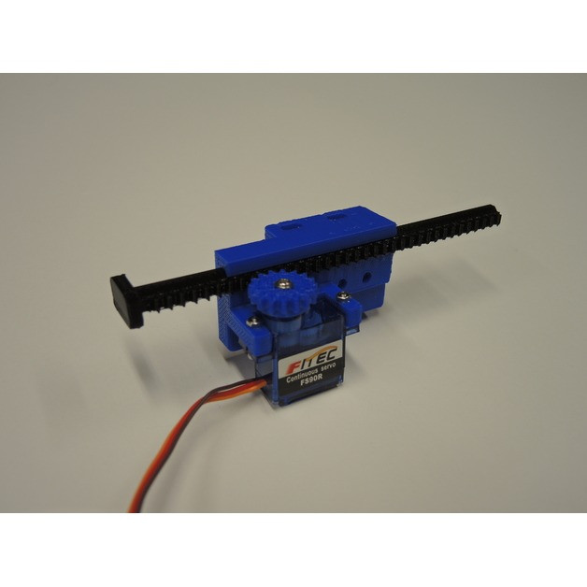

Rack

Servo motor

Pinion gear

An example for Ball pushing mechanism (actual design may differ)

### **Score tracking**

In our scoring system, an IR Break Beam Sensor is employed to detect whether the ball has entered the goal. When a player scores a point, the IR Break Beam Sensor registers this event and sends the signal to a Raspberry Pi. Subsequently, the Raspberry Pi communicates the scoring information to an Arduino Uno board, ensuring real-time score updates during gameplay.

### **Ball Redeploy Mechanism**

A built-in inclined plane in the hole, guides the ball to the right corner within the goal. Using a servo motor and a rack and pinion mechanism, the ball is lifted to table level. Once elevated, the same mechanism generates a pushing effect, redeploying the ball back into the play area. This simple yet effective system ensures a smooth and consistent ball redeployment process after scoring.

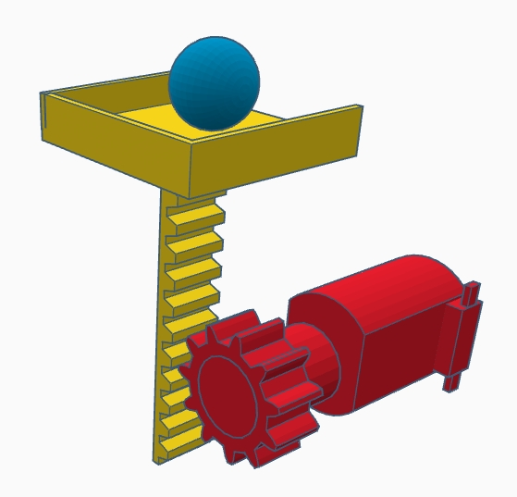

continuous Servo motor

(static position)

An example for Ball lifting mechanism (actual design may differ)

# **Block Diagram**

Camera Module

Push Buttons

LCD screens

(scores)

12C modules

Stepper Motors

Raspberry PI

Arduino UNO

Buzzers

A4988

LEDs

Servo motors

Mode selection LCD screen

12C module

IR Break Beam Sensors

Keypad

# **Design**

Scores

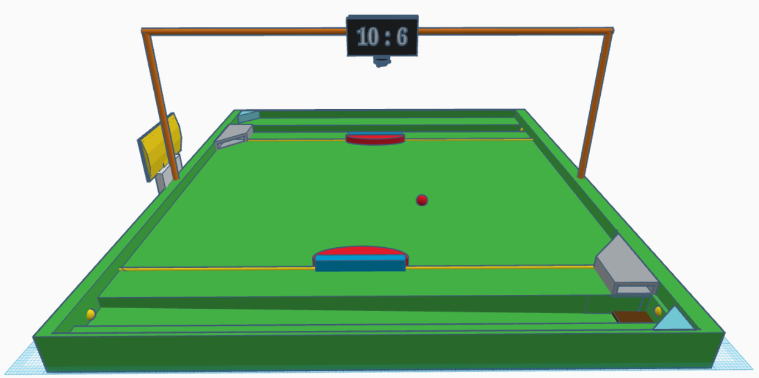

Camera

Ball Redeploy Mechanism

Hole

Ball

Paddle

IR Break Beam Sensor

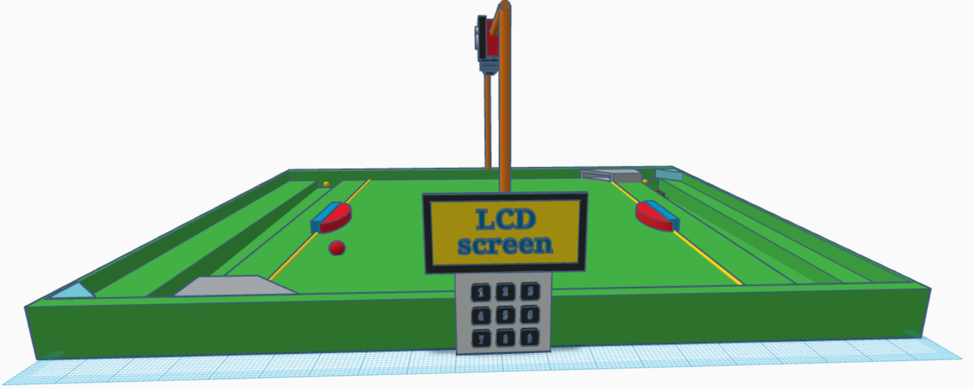

Mode Selection LCD Screen

Keypad

# **References**

OpenCV Documentation

* <https://docs.opencv.org/3.4/df/d9d/tutorial_py_colorspaces.html>
* <https://docs.opencv.org/3.4/da/d97/tutorial_threshold_inRange.html>
* <https://docs.opencv.org/4.x/d3/d05/tutorial_py_table_of_contents_contours.html>

OpenCV YouTube Tutorial

* <https://www.youtube.com/watch?v=eDIj5LuIL4A>

Mechanisms for converting Rotational Motion into Linear

* <https://youtu.be/ve9M8d6KfdI?si=8PxCvQbe-xPVnI0p>

Other Links –

* <https://blog.arduino.cc/2018/10/29/linear-movement-with-arduino-and-3d-printing/>
* <https://openbuildspartstore.com/v-slot-nema-17-linear-actuator-bundle-belt-driven/>